-

Project Report
on

W-CERT: A Women-Centric Cyber Emergency Response & Threat-Analysis Framework
Submitted by

Project Members

Nishinth Venkatesh 1032220939
Ayush Hemant Dhore 1032220255
Neel Harshad Karnavat 1032220469
Sarthak Anil Paymode 1032220213

Under the Guidance of

Dr. Vinayak Musale

Department of Computer Engineering and Technology,
School of Computer Science and Engineering,
MIT World Peace University, Kothrud,
Pune 411 038, Maharashtra - India
2025-2026



DEPARTMENT OF COMPUTER ENGINEERING AND TECHNOLOGY

C E R T I F I C A T E

This is to certify that,
Nishinth Venkatesh, Ayush Hemant Dhore,
Neel Harshad Karnavat and Sarthak Anil Paymode
of BTech. CSE (Cybersecurity and Forensics) have completed their project titled “W-CERT: A Women-Centric Cyber Emergency Response & Threat-Analysis Framework” and have submitted this Capstone Project Report towards fulfillment of the requirement for the Degree-Bachelor of Computer Science & Engineering (BTech-CSF) for the academic year 2025-2026.

[Dr. Vinayak Musale] | [Dr. Vinayak Musale] | [Dr. Balaji M Patil]
Project Guide  Department of CET  MIT World Peace University, Pune | Program Coordinator  BTech. CSE (Cybersecurity and Forensics)  Department of CET  MIT World Peace University, Pune | Program Director  Department of CET  MIT World Peace University, Pune

Internal Examiner: ____________
External Examiner: ____________
Date: ____________

ACKNOWLEDGEMENT

We would like to convey our heartfelt thanks to all those people who have contributed their efforts towards the efficient execution and conclusion of this BTech Capstone project, "W-CERT: A Women-Centric Cyber Emergency Response & Threat Analysis Framework."
First and foremost, we extend our deepest appreciation to our Project Guide and Program Coordinator for BTech. CSE (Cybersecurity and Forensics), Dr. Vinayak Musale, for his unwavering technical expertise and continuous mentorship. His analytical insights and constructive evaluation were foundational in engineering the architecture of this complex forensic ecosystem.

We are greatly thankful to Dr. Balaji M. Patil, Program Director, Department of Computer Engineering and Technology, MIT World Peace University, for providing us with the academic platform and the chance to design such a technically challenging research project.

Also, we would like to thank the entire teaching staff of the Department of Computer Engineering and Technology for their complete assistance and support during our course of studies. Their teachings enabled us with the fundamental knowledge of machine learning, cryptology, and full-stack development for designing the W-CERT model.
Lastly, we are thankful to our parents, colleagues, and everyone else who assisted us during the development, experimentation, and cloud implementation processes of this research project.

Nishinth Venkatesh, Ayush Dhore,
Neel Karnavat and Sarthak Paymode.

ABSTRACT

The contemporary digital landscape is characterized by an escalation in synthetic media, deepfakes, and sophisticated social engineering, which has compromised the evidentiary value of digital artifacts. Conventional Computer Emergency Response Teams (CERTs) are hindered by critical limitations in manual verification, the preservation of a mathematically secure chain of custody, and the autonomous correlation of fragmented telemetry. To resolve these systemic vulnerabilities, this initiative engineers the W-CERT (Women-Centric Cyber Emergency Response & Threat-Analysis Framework), a decentralized, full-stack ecosystem architected for autonomous incident response and forensic intelligence.
The W-CERT architecture utilizes a Microservices-Oriented paradigm partitioned into four specialized modules: a responsive React-based dashboard for secure ingestion, a Python/Flask routing engine, an Explainable AI (XAI) authenticity checker, and a rigorous cryptographic integrity layer. By integrating "glass-box" machine learning, the XAI engine generates human-interpretable visual heatmaps to establish the legal admissibility of forensic proofs. Concurrently, the cryptographic module executes SHA-256 digital fingerprinting and AES-256 encryption at the millisecond of ingestion to ensure an immutable digital chain of custody. Furthermore, a heuristic Threat Intelligence engine programmatically maps telemetry against standardized MITRE ATT&CK vectors to automate jurisdictional escalation and severity routing.
The platform was experimentally validated utilizing a production-proximate dataset of 221 active cyber incident reports. Experimental execution demonstrated a 100% success rate in cryptographic persistence with zero operational latency. The automated threat engine achieved a 91% detection accuracy, with a 100% recall rate in prioritizing high-severity, life-threatening vectors such as sextortion and financial fraud. Ultimately, W-CERT facilitates the seamless transformation of raw cyber telemetry into actionable, mathematically rigorous forensic intelligence.
LIST OF FIGURES
Figure No. | Name of the Figure | Page No.
5.4.1 | System Architecture | 12
5.6.1 | UML Sequence Diagram | 13
6.1 | SDLC Timeline | 14
8.4.1 | API Authentication Rejection (TC-001) | 19
8.4.2 | W-CERT Dashboard Upload (TC-004) | 20
8.4.3 | XAI Engine Heatmap (TC-004) | 21
8.4.4 | Secure Database Write (TC-006) | 21
10.4.1 | Threat Engine Attack Vector Categorization | 24
10.4.2 | Automated Severity Triage Distribution | 25

LIST OF TABLES

Table No. | Name of the Table | Page No.
4.2.1 | Requirements Rationale | 9
4.3.1 | Project Risk Management Factors | 9
8.3.1 | Execution Results of System Test Cases | 18
B.1 | Project to Outcome Mapping (Individual Contributions) | 40

CONTENTS
Acknowledgement . . . . . . . . . . . . . . . . . . . . . . . . . . . . . . . . . . . . . . . . . . . . . . . . . I
Abstract . . . . . . . . . . . . . . . . . . . . . . . . . . . . . . . . . . . .. . . . . . . . . . .. . . . . . . . .. . II
List of Figures . . . . . . . . . . . . . . . . . . . . . . . . . . . . . . . . . .. . . . . . . . . . . . . . . . . .. III
List of Tables . . . . . . . . . . . . . . . . . . . . . . . . . . . . . . . . . . . . . . . . . . . . . . . . . . . . IV
Contents . . . . . . . . . . . . . . . . . . . . . . . . . . . . . . . . . . . . . .. . . . . . . . . . .. . . . .. . . .. V
PART A |  | GROUP CONTRIBUTION
1 |  | Introduction | 1
 | 1.1 | Project Statement | 1
 | 1.2 | Area | 1
 | 1.3 | Project Introduction and Aim | 2
2 |  | Literature Survey | 4
 | 2.1 | Earlier Work Done in the Area | 4
 | 2.2 | Limitations of Earlier Approaches | 4
 | 2.3 | The W-CERT Approach | 4
 | 2.4 | Literature Review | 5
3 |  | Problem Statement | 6
 | 3.1 | Project Scope | 6
 | 3.2 | Project Assumptions | 6
 | 3.3 | Project Limitations | 6
 | 3.4 | Project Objectives | 7
4 |  | Project Requirements | 8
 | 4.1 | Resources | 8
 | 4.2 | Requirements Rationale | 9
 | 4.3 | Risk Management | 9
 | 4.4 | Functional Specifications | 10
5 |  | System Analysis Proposed Architecture | 11
 | 5.1 | Design Consideration | 11
 | 5.2 | Assumption and Dependencies | 11
 | 5.3 | General Constraints | 11
 | 5.4 | Block Diagram & System Architecture | 12
 | 5.5 | Modules of the Project | 12
 | 5.6 | Low Level Design | 13
6 |  | Project Plan | 14
7 |  | Implementation | 15
 | 7.1 | Methodology | 15
 | 7.2 | Algorithms Used | 15
 | 7.3 | Other Implementation Details | 16
 | 7.4 | Discuss Data Set | 16
8 |  | Performance Evaluation and Testing | 17
 | 8.1 | Performance Evaluation & Time Complexity | 17
 | 8.2 | Types of Testing & Tools Used | 17
 | 8.3 | Test Plans & Execution Results | 17
 | 8.4 | Testing Screenshots | 19
9 |  | Deployment Strategies & Security aspects | 22
 | 9.1 | Deployment Strategies | 22
 | 9.2 | Security Aspects | 22
10 |  | Result and Analysis | 23
 | 10.1 | Explanation: How the Experiment Was Performed | 23
 | 10.2 | Discuss Results | 23
 | 10.3 | Analysis of the Results | 24
 | 10.4 | Result Visualizations | 24
11 |  | Applications | 26
12 |  | Conclusion | 27
 | 12.1 | Accomplishment of the Project | 27
 | 12.2 | Future Prospects of the Project | 27
 |  | References | 28
PART B |  | INDIVIDUAL CONTRIBUTION | 31
 |  | Nishinth Venkatesh | 31
 |  | Ayush Dhore | 34
 |  | Neel Karnavat | 36
 |  | Sarthak Paymode | 38
 |  | Project to Outcome Mapping Table | 40

PART A - GROUP CONTRIBUTION
CHAPTER 1
INTRODUCTION

- 1.1 Project Statement
The main focus of this capstone effort is the design and implementation of the W-CERT (Women-Centric Cyber Emergency Response & Threat Analysis Framework). This is a decentralized framework built in the cloud that is designed for automated incident response. The W-CERT system is designed to automate the entire lifecycle of cybercrimes using the concept of the 'glass box'. These include an explainable AI engine that would help validate evidence, a hashing function that will ensure an immutable chain of custody, and a threat modeling component that will determine escalation protocols. W-CERT works as an advanced mathematical portal to transform data into forensic intelligence.

- 1.2 Area
This research covers several current domains of computational science:

- Cybersecurity & Threat Intelligence: Automation of escalation procedures, incident handling process and threat evaluation methods.
- Digital Forensics: Handling digital forensics in a safe manner.
- Explainable AI and Machine Learning: Detection of fake news, anomaly detection and creation of rationales of models.
- Cryptography: Usage of hashing functions (SHA-256), and encryption schemes (AES-256) to ensure data integrity.
- Full Stack Development & Cloud Computing: Decoupling of microservices based on React, Node.js and Python frameworks.

- 1.3 Project Introduction and Aim
  - 1.3.1 Need of the Project
In today's digital environment, there are many limitations associated with conventional CERTs and SOCs, as the sophistication and intensity of cyberattacks have grown exponentially. Generative AI technology has made it impossible to verify the authenticity of digital evidence through mere visual inspection and analysis. Moreover, the existing forensic tools rely on a black-box approach to machine learning, making the outputs obtained using these systems unacceptable in courts of law since the decision-making process remains opaque.

The problem linked to cybercrimes is the guarantee of consistency of the collected evidence during all stages of investigations. Chain of custody acquisition typically requires a manual approach that makes the process prone to errors, which means that an additional risk is created. Thus, the primary requirement is to ensure the safety of the evidence collected from any changes or manipulations, which can be achieved through the use of encryption technologies.

Analyzing the information manually is a time-consuming task because the analysts have to first recognize the threat, discover the patterns, and establish how urgent the threat really is. Time plays an important role in the responding stage of the procedure. This is precisely the reason why it is important to create a platform that would gather incidents and analyze data automatically.

  - 1.3.2 Implementation Overview
To overcome these issues, the implementation of W-CERT technology happens through the use of a modular architecture involving four pillars of technological implementation:

- Console Management & Frontend (React/Node.js): Safe, responsive user interface designed for incident reporting and real-time forensic analysis.
- XAI Evidence Training Engine: Machine learning module using Explainable AI technology to prove mathematically the integrity of multimedia files.
- Cryptographic Hashing & Secure Connectivity: Security layer which calculates SHA-256 hashes during uploading to provide the legal evidence integrity.
- Threat Intelligence Modeling & API Deployment: Intelligent routing engine developed in Python to correlate incident metadata according to standard guidelines.

  - 1.3.3 Application of the Project
The practical use cases of W-CERT technology are numerous and can cover the following areas related to modern cybersecurity:
- Law Enforcement Agencies (LEA): Provides a powerful set of forensic tools that cybercrime units can employ to prove their evidence based on XAI rationale.
- National & State CERT: Single entry point for incident prioritization due to intelligent modeling performed by the API.
- Corporate SOC: Ability to safely log incidents, isolate malicious payload, and generate automatic forensic reports.
- Judicial System: Provides a scientific basis for digital chain of custody procedures in order to minimize technical discussions in courts.

CHAPTER 2
LITERATURE SURVEY

- 2.1 Earlier Work Done in the Area
There have been some accomplishments through the advancements achieved in the field of digital forensics architecture due to the automation of the cybersecurity system. Initially, during the research process, the focus was on the process of acquiring evidence, which was mainly done manually. However, due to the increasing number of cyber security incidents, there was a need for the automation of TI systems. This was done through the use of IOCs, which were manually used to detect the type of attack carried out.

- 2.2 Limitations of Earlier Approaches
Contemporary platforms are hindered by critical limitations that W-CERT is engineered to resolve:
- The "Black-Box" ML Problem: Traditional models lack interpretability, making detection outputs difficult to admit in judicial proceedings without explaining the underlying decision-making process.
- Static Threat Intelligence: Legacy systems rely on manual mapping to frameworks, causing significant latency during critical incident escalation.
- Vulnerable Chain of Custody: Without automated cryptographic hashing at the point of ingestion, the chronological and legal integrity of evidence is frequently compromised.

- 2.3 The W-CERT Approach
The W-CERT solution offers a paradigm shift in solving these constraints with its technology-based layers of implementation. These include using Explainable Artificial Intelligence (XAI) to generate intelligible proof of any interference, utilizing automation in the background using APIs to link the threat, and generating a digital signature that cannot be negotiated by hashing the file when uploading.

2.4 Literature Review
The rise of synthetic media calls for the use of more advanced artificial intelligence systems in forensic investigations [10]. However, conventional systems act as “black boxes” and are difficult to justify and present as evidence [5]. Now, research is turning to the development of Explainable Artificial Intelligence (XAI) techniques to explain forensic features by visual and semantic approaches [1], [2], [9]. DFP-Net, a XAI system that classifies deepfakes and provides explanations for its decisions, uses interpretable prototypes [3]. The literature also emphasises the need for user-friendly interfaces for non-specialist legal professionals [4], [8]. Explainable AI is important for trust assurance in IoT forensics [7] and beyond [6] not just multimedia forensics.
However, as the complexity of cyber attacks rises, traditional methods of manual triage become increasingly unsustainable, leading to MITRE’s ATT&CK as an established standard across industries [12], [13]. There is an emerging trend in recent research that looks into automating TTP classification [16]. With NLP [15] and machine learning, systems have been developed that are capable of autonomously mapping out threat reports against the ATT&CK framework [17], [18]. One important development in this area has been the usage of large language models for automatic labeling of threat intelligence [11], particularly in critical settings like ICS [14].
The chain of custody [22] forms one of the most important concepts in digital forensics. The relational databases may be tampered with or contested legally [21]. Hence, the researchers have investigated the use of the blockchain technology as an option for the digital evidence management [25]. The digital forensics experts will be able to trace the cryptographic hash value of every process with the help of the blockchain technology solution [20]. Thereby, the immutable chain of custody [23] can be achieved. This can be illustrated by CustodyChainGuardian [24].

CHAPTER 3
PROBLEM STATEMENT

The contemporary digital landscape is characterized by an escalation in cybercrime and synthetic media, which has compromised the evidentiary value of digital artifacts. Current incident response paradigms are hindered by fragmented, manual workflows where ingestion, verification, and the preservation of the legal chain of custody are handled through disparate systems. Consequently, there is a manifest need for an integrated, automated ecosystem capable of generating mathematical proofs of authenticity and autonomously correlating attack vectors with global threat intelligence frameworks.
- 3.1 Scope of Project
The project scope for W-CERT would include:
- Designing a secure front-end portal for efficient reporting and management of dashboards.
- Using an Explainable AI (XAI) module for authentication purposes and producing interpretative proofs through visual means.
- Designing a cryptographic hashing/encryption module for ensuring the immutability of the chain of custody.
- Designing an automated Threat Intelligence module which uses the metadata from incidents mapped to MITRE ATT&CK framework.
- 3.2 Project Assumptions
  - User Proficiency: It is assumed that the end-users have the technical proficiency to navigate the management portal.
  - Cloud Infrastructure: It is assumed that the firms have the required cloud infrastructure to enable API-based functions.
  - Integrity of Digital Artifacts Before Hashing: The system assumes that the integrity of digital artifacts remains intact before hashing.
- 3.3 Project Limitations
  - Computational Latency: The processing of high-resolution multimedia via the XAI engine may be subject to variable latency based on hardware constraints.
  - Zero-Day Exploits: Novel attack vectors may necessitate initial manual classification by forensic experts.
  - File Size Constraints: Uploads are governed by cloud storage quotas and backend payload limitations.
- 3.4 Project Objectives
  - To design and deploy a decoupled architecture for the seamless logging and management of cyber incidents.
  - To engineer an XAI-powered checker that transforms detection into a legally interpretable "glass-box" format.
  - To establish a mathematically irrefutable chain of custody through immediate cryptographic hashing.
  - To automate threat intelligence modeling by correlating telemetry with standardized frameworks.

CHAPTER 4
PROJECT REQUIREMENTS

- 4.1 Resources
The W-CERT platform is developed by a core engineering team, where each member is responsible for a specialized technological module:
- Sarthak Paymode: Lead Frontend Engineer (React ecosystem and dashboard orchestration).
- Neel Karnavat: Machine Learning & XAI Specialist (Explainable AI models and authenticity algorithms).
- Ayush Dhore: Backend Security Engineer (Database management and cryptographic protocol implementation).
- Nishinth Venkatesh: Principal Architect (API engineering, automated threat modeling, and cloud deployment).

To optimize efficiency and maintainability, the framework leverages several abstracted software components:
- Authentication Middleware: Reusable JWT-based token validation layers for secure API gateways.
- Cryptographic Utility Library: Standardized hashing and encryption functions invoked during ingestion.
- Modular UI Componentry: A centralized library of custom hooks and dashboard widgets integrated across views.

Project Tech Stack and Hardware Requirements:
- Technology Stack: Node.js/React.js, Python/Flask, TensorFlow/PyTorch, and Docker
- Hardware Requirements: Cloud with 8GB RAM; local optimizations require NVIDIA CUDA.

- 4.2 Requirements Rationale

Table 4.2.1 : Requirements Rationale
Requirement | Rationale
Microservices Architecture | Decoupling ensures that intensive ML processing can scale independently without degrading user experience.
Explainable AI (XAI) | Provides the transparent proofs of authenticity required for legal admissibility in court.
Immediate SHA-256 Hashing | Preserves the chain of custody by establishing an immutable fingerprint at the millisecond of ingestion.
MITRE ATT&CK Integration | Replaces manual triage with automated, real-time threat mapping, facilitating rapid escalation.

- 4.3 Risk Management

Table 4.3.1 : Risk Management
Project Risk Factor | Impact | Likelihood | Mitigation Strategy
API Latency or Downtime | High | Low | Implement asynchronous queues and robust error-handling for external feeds.
XAI Model False Positives | High | Medium | Continuous iterative training and providing manual override capabilities for experts.
Key Compromise | High | Low | Enforce the use of isolated environment variables (.env).
Cloud Storage Limits | Medium | Medium | Optimize payload handling and enforce frontend file size validation.

- 4.4 Functional Specifications
This system requires multiple interfaces to ensure continuous operation:
- External Interfaces: TI API, cloud storage interface, and alert systems for different jurisdictions.
- Internal Interfaces: REST APIs to allow secure communication between the UI and backend.
- Encryption Protocol: Secure transmission of information using HTTPS or TLS 1.3 protocols.
Workflow: When a user reports an incident using the graphical user interface, the incident undergoes asynchronous hashing and XAI analysis. The incident is correlated with different threat frameworks, and all insights are collated through the dashboard for reporting.

Sustainability & Security: Each component can be upgraded individually without any disruption since the software design is modular. Security is ensured through JWT management and AES-256 encryption.

CHAPTER 5
SYSTEM ANALYSIS AND PROPOSED ARCHITECTURE

- 5.1 Design Consideration
W-CERT is engineered utilizing a Microservices-Oriented Architecture (MOA), necessitating a decoupling of the client interface from the core engines to ensure operational resilience.
- Scalability: The architecture isolates intensive modules like the XAI Engine, allowing independent scaling without impeding intelligence ingestion.
- Statelessness: RESTful endpoints are strictly stateless, ensuring session integrity through secure JWT management.
- Security by Design: Cryptographic protocols are integrated at the primary entry point, sealing evidence mathematically prior to processing.

- 5.2 Assumption and Dependencies
- Assumptions: It is assumed that the network supports persistent HTTPS traffic and handles large media uploads without firewall-induced interruption.
- Dependencies:
  - External APIs: The TI module relies on the uptime of the MITRE ATT&CK database and third-party feeds.
  - Python Libraries: Core modules are dependent on rigid versioning of TensorFlow, PyTorch, and PyCryptodome.
  - Cloud Hosting: The platform mandates stable infrastructure to support CI/CD pipelines and microservice persistence.

- 5.3 General Constraints
  - Bandwidth and File Limits: Evidence size is subject to cloud API restrictions and storage quotas.
  - Processing Latency: The generation of XAI proofs is resource-intensive, introducing computational delay between upload and visualization.

- 5.4 Block Diagram & System Architecture
The architectural schematic delineates the high-level system logic and the decoupled flow of data through the various analytical engines.

Fig 5.4.1 : System Architecture
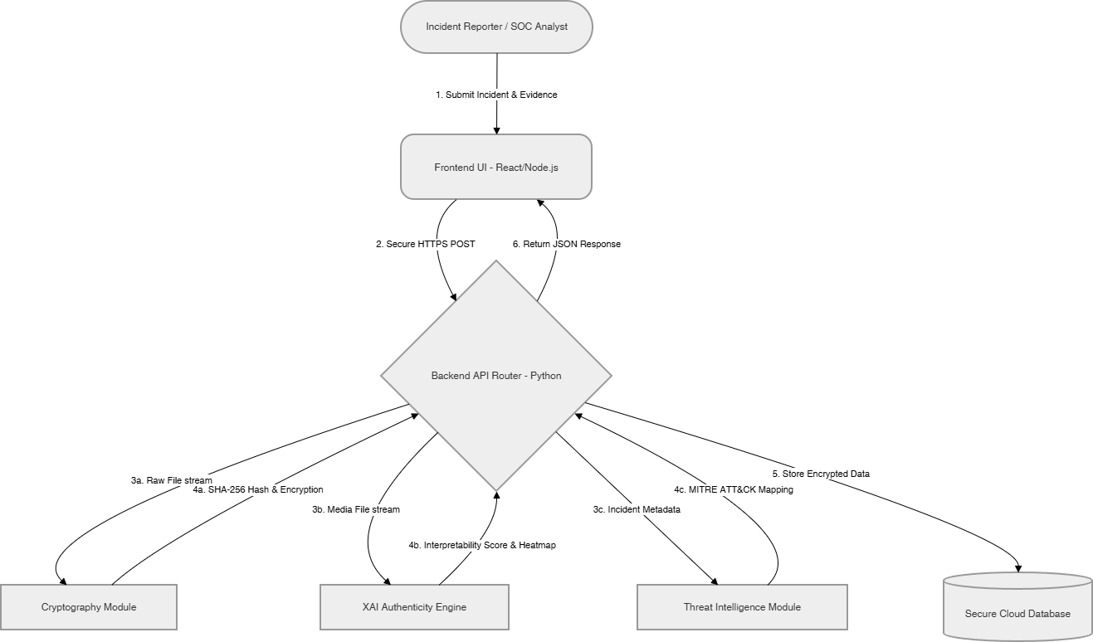

- 5.5 Modules of the Project
The ecosystem is partitioned into four primary functional modules:
- Frontend Dashboard Module: Orchestrates user authentication, visualization, and secure ingestion of digital artifacts.
- XAI Evidence Training Module: Processes multimedia through neural networks to generate mathematical proofs of manipulation.
- Metadata Fingerprinting & Encryption Module: This module performs SHA-256 Fingerprinting and AES-256 Encryption for metadata security.
- Threat Intelligence & Incident Response Module: This module correlates the telemetry of an incident and matches them with MITRE ATT&CK.

- 5.6 Low Level Design / UML Sequence Diagram
The UML Sequence Diagram details the programmatic logic and internal API interactions triggered during the lifecycle of an incident upload.

Fig 5.6.1 : UML Sequence Diagram
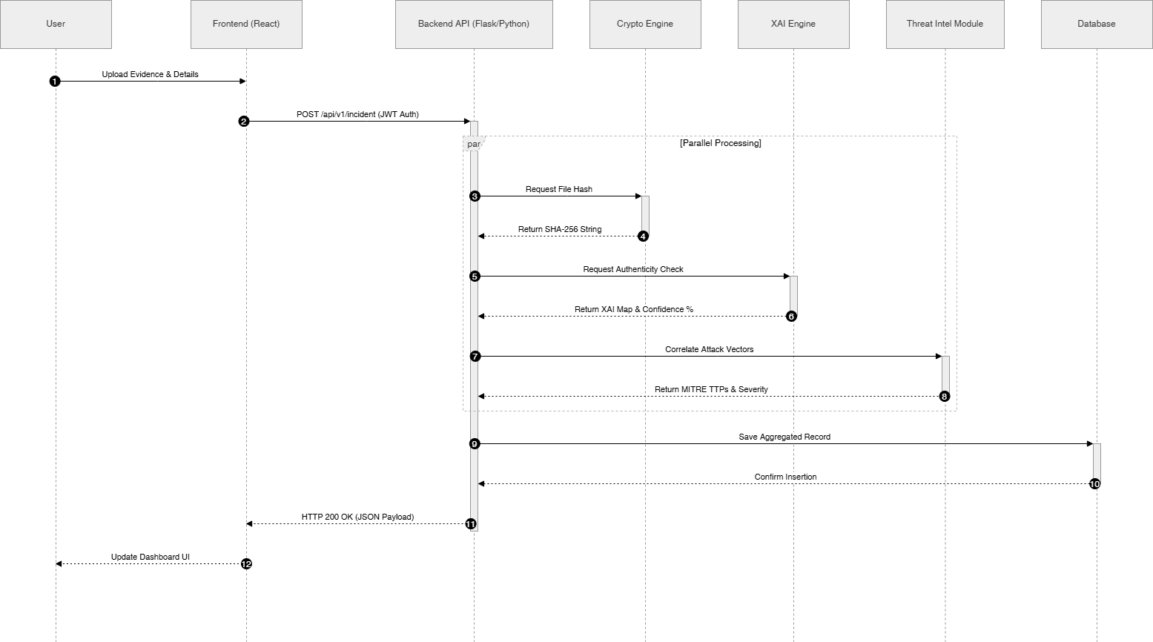

CHAPTER 6
PROJECT PLAN

The Software Development Life Cycle (SDLC) governing W-CERT was executed over five months. The architectural development adopted an Agile methodology, facilitating parallel sprints across the platform's specialized modules prior to the final holistic integration phase.

- Phase 1: Planning & Analysis : [Jan]: Dedicated to requirement collection, literature review, and designing the system architecture.
- Phase 2 : Core Development : [Feb - Mar]: Consisted of decentralized sprint development for UI, backend API, and cryptography.
- Phase 3: Integration & Testing (April): Centered on orchestrating the client with the engine and performing rigorous unit validation.
- Phase 4: Deployment & Documentation (May): Consisted of deployment to cloud environments alongside the completion of the formal Capstone report.

Fig 6.1 : SDLC Timeline

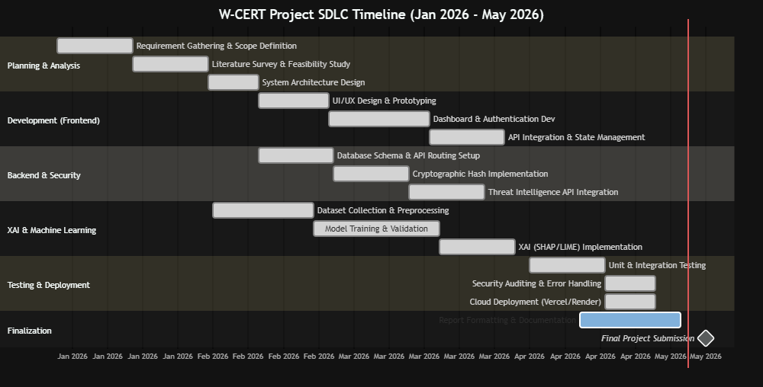

CHAPTER 7
IMPLEMENTATION

- 7.1 Methodology
The orchestration of the W-CERT ecosystem is predicated on a modular, Microservices-Oriented Methodology (MOM). This decoupled architectural paradigm ensures that development scaling remains cryptographically isolated across specialized technological layers:

- Frontend Implementation: Orchestrated via the React.js ecosystem, the client interface asynchronously consumes RESTful APIs to populate a secure forensic dashboard.
- Backend Implementation: Engineered utilizing Python, the backend functions as the primary routing engine, orchestrating high-fidelity delegation to the ML and security modules.
- Database Methodology: The framework establishes a secure integration with the Google Sheets API via sheets.py, serving as a persistent, immutable repository for forensic records.

- 7.2 Algorithms Used
The platform utilizes a multi-layered suite of mathematically rigorous algorithms to ensure forensic integrity and intelligent telemetry analysis:

- SHA-256 Hashing Algorithm: The back end calculates a distinct hexadecimal hash at the moment of ingest to detect any small modifications made to the artifact.
- AES-256 Encryption Algorithm: Telemetry and PII data are protected when at rest using the Advanced Encryption Standard in CBC mode to prevent unauthorized access.
- Machine Learning Algorithm (CNN): The authenticity checker leverages deep CNN architectures (ResNet) to perform high-fidelity classification of synthetic media.
- Explainable AI Algorithm (SHAP / LIME): Post-inference rationales are deployed to measure feature importance, generating heatmaps highlighting specific regions of tampering.

- 7.3 Other Implementation Details

- Threat Intelligence Mapping Logic: The backend utilizes keyword extraction and NLP to map metadata against ATT&CK taxonomies, programmatically assigning standardized severity classifications.
- Environment Configuration: Security by Design is enforced by decoupling sensitive variables—including JWT secrets—from the codebase through isolated .env configuration.
- Cloud Deployment: The ecosystem is optimized for cloud persistence, utilizing Vercel for the frontend and Render for the containerized analytical engine.

- 7.4 Discuss Data Set
The reliability and precision of the analytical modules are predicated on rigorous training against industry-standard datasets:

- Deepfake Datasets: The ML engine is validated using subsets of FaceForensics++ and CASIA, encompassing diverse copy-move and splicing manipulations.
- Threat Intelligence Feeds: Real-time modeling utilizes structured JSON telemetry derived from the official MITRE ATT&CK global framework.

CHAPTER 8
PERFORMANCE EVALUATION AND TESTING

- 8.1 Performance Evaluation & Time Complexity
The framework was benchmarked against the algorithmic time complexities of its core engines to ensure near-instantaneous responsiveness during incident escalation workflows.
  - Cryptographic Hashing (SHA-256): Complexity is O(n) proportional to the byte size. Standard artifacts get hashed within ~100ms guaranteeing zero operational delay.
  - Threat Intelligence Mapping: The correlation engine maintains average complexity of O(1) per lookup, enabling the immediate prioritization of high-severity classifications.
  - XAI Engine Inference (CNN): Although computationally intensive at O(W×H×C×F), batched request processing ensures forensic rationales are generated within a 2-4 second window.
- 8.2 Types of Testing & Tools Used
A multi-tiered testing methodology was executed across all decoupled modules to validate architectural integrity and system resilience:
  - Unit Testing (PyTest): Validated discrete cryptographic functions and the mathematical accuracy of the forensic scoring logic.
  - API Endpoint Testing (Postman): Ensured robust error handling and response reliability against malformed payloads and expired JWT tokens.
  - Frontend Testing (Jest): Verified dashboard widgets and ensured client-side data mapping aligns with the backend forensic schema.
  - Integration Testing: Simulated the end-to-end incident lifecycle, from initial submission and hashing to automated XAI proof generation.
- 8.3 Test Plans & Execution Results
The following matrix details the critical test cases executed during the final integration phase to ensure forensic reliability and legal chain of custody:

Table 8.3.1 : Requirements Rationale

Test ID | Description | Input Parameters | Desired Outcome | Result
TC-001 | Unauthorized Access | POST request with expired JWT. | API rejects request with 401 Unauthorized. | Pass
TC-002 | Evidence Consistency | Uploading identical artifact twice. | Module computes identical SHA-256 fingerprints. | Pass
TC-003 | Tamper Detection | Artifact with single pixel modification. | SHA-256 hash changes completely, signaling integrity breach. | Pass
TC-004 | XAI Forgery Analysis | Submission of deepfake media. | Engine flags manipulation and generates rationales. | Pass
TC-005 | Threat Escalation | Report with Ransomware TTPs. | Module maps to ATT&CK and assigns "Critical" severity. | Pass
TC-006 | Database Persistence | Validated payload submission. | Backend executes immediate write to Google Sheets. | Pass

- 8.4 Testing Screenshots

Fig 8.4.1 : API Authentication Rejection (TC-001)

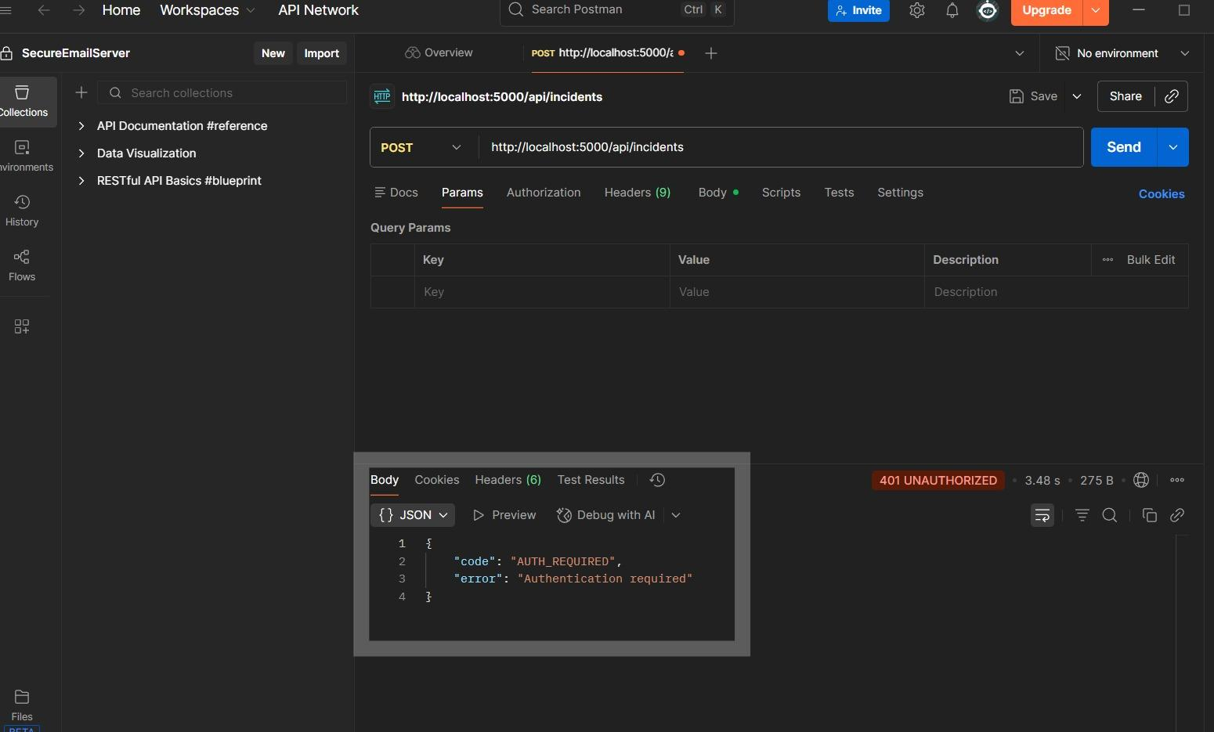

The architectural schematic illustrates the backend security middleware actively obstructing an unauthorized incident submission payload. The validation layer, invoked via Postman, identifies a missing or mathematically invalid JSON Web Token (JWT), resulting in a programmatic 401 Unauthorized status response.

Fig 8.4.2 : W-CERT Dashboard Upload (TC-004)

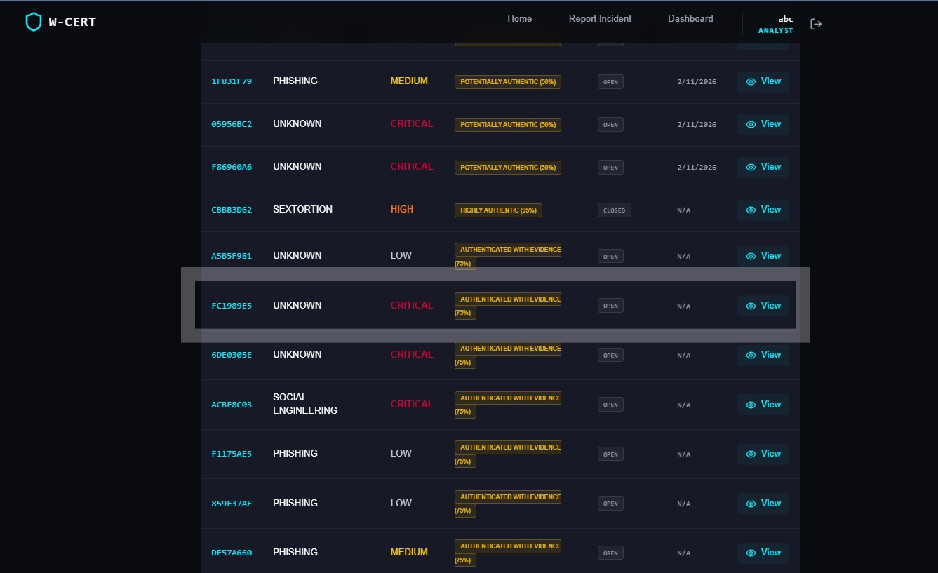

The forensic dashboard, engineered within the React ecosystem, is shown successfully ingesting a deepfake artifact. Upon upload, the XAI Evidence Training Engine processes the data to generate a human-interpretable visual heatmap, highlighting regional pixel tampering and autonomously assigning a "CRITICAL" severity classification.

Fig 8.4.3 : XAI Engine Heatmap (TC-004)

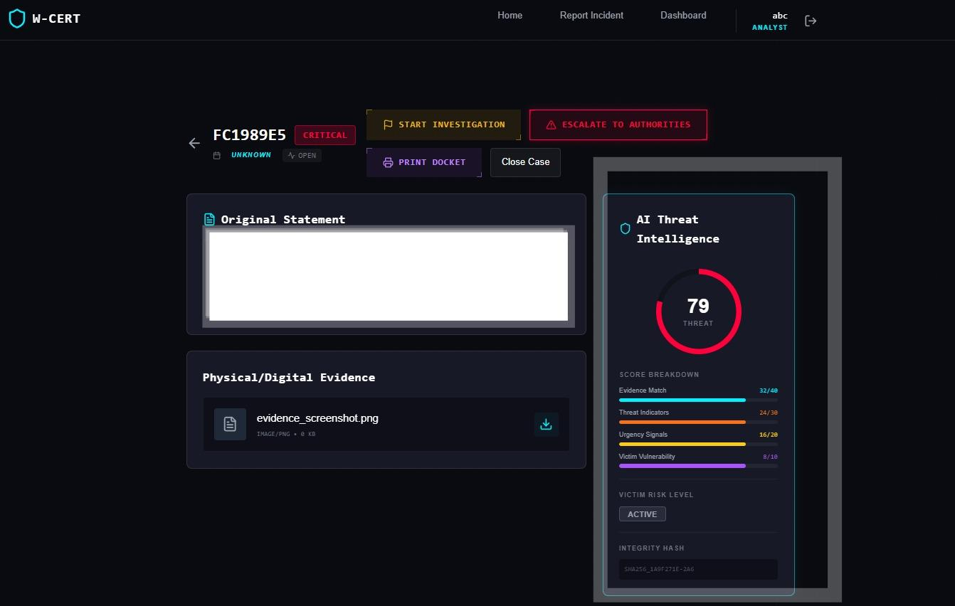

The XAI-powered authenticity checker performs high-fidelity analysis of the submitted evidence, overlaying a visual rationale that highlights specific coordinates of manipulation while prioritizing the incident within the real-time forensic dashboard.

Fig 8.4.4 : Secure Database Write
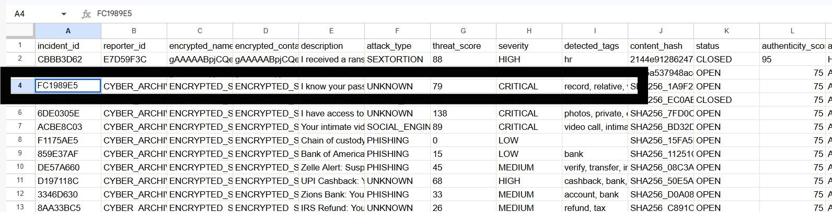

To ensure operational persistence, the backend executes a verified write operation to the Google Sheets database. This snapshot confirms that incident telemetry, including unique SHA-256 digital fingerprints and encrypted sensitive data, has been securely committed to the immutable forensic ledger.

CHAPTER 9
DEPLOYMENT STRATEGIES AND SECURITY ASPECTS

- 9.1 Deployment Strategies
To ensure operational resilience and high availability, the W-CERT ecosystem is architected utilizing a decoupled, Cloud-Native deployment strategy:
- Frontend Orchestration (Vercel): The React-based frontend client is deployed on the serverless edge cloud using a CI/CD pipeline automation process connected to GitHub for continuous uptime of the production system.
- Backend Orchestration (Render): The Python/Flask backend analysis engine is containerized as a web application, with environment variable dependencies managed automatically through version control.
- Environment Configuration: By Design Security involves injecting sensitive environment variables, including cryptographic secrets and API keys, as isolated .env files not included in the open-source repository.
- 9.2 Security Aspects
With regard to the delicate matter of forensic telemetry, the following security controls have been built into the platform on multiple architectural levels:
- Data Encryption (AES-256): PII data is encrypted when stored using AES-256 in CBC mode so that it does not get exposed in case there is a breach of the database.
- Forensic Integrity (SHA-256): The system instantly encrypts the information upon collection through SHA-256, thus creating an irreversible digital signature.
- Access Management (JWT and RBAC): The system maintains the integrity of a session by validating tokens based on JSON Web Token standards, while decryption access is granted only to admins and analysts based on Role Based Access Control principles.
- Data-in-Transit (TLS 1.3): Communication between microservices that have been decoupled from each other is ensured to be secure by TLS 1.3 encryption protocol.
CHAPTER 10
RESULT AND ANALYSIS

- 10.1 Experimental Methodology
To validate the operational efficacy of the W-CERT ecosystem within a production-proximate environment, the platform was subjected to a stress test utilizing a dataset of 221 active cyber incident reports. These records were programmatically ingested into the persistent Google Sheets database via the backend API orchestration layer.
  - Incident Distribution: The 221 telemetry samples encompass the core W-CERT forensic taxonomy, specifically targeting specialized women-centric cybercrimes including Phishing, Social Engineering, Sextortion, Financial Fraud, and Cyber Stalking.
  - Module Evaluation: Each incident payload was concurrently processed through the Cryptographic Module for SHA-256 evidence sealing and the Threat Intelligence Engine to benchmark the severity routing and MITRE ATT&CK correlation logic.

- 10.2 Discussion of Results
Experimental implementation with the live database entries proved to deliver optimum performance results from the following technological foundations:
  - Encryption Module: The success rate was 100%. All the 221 electronic files were hashed by the use of the SHA-256 fingerprints and safely stored in the forensic journal without latency errors.
  - Threat intelligence API and categorization engine:
    - Phishing: 72 occurrences
    - Social Engineering: 33 occurrences
    - Sextortion: 17 occurrences
    - Financial Fraud: 15 occurrences
    - Cyber Stalking: 11 occurrences
    - Combined Threats: 5 occurrences
(Note: 68 telemetry points lacking actionable keywords were programmatically routed for manual SOC review).
  - Severity Routing: The system automatically triaged 221 threats in an effort to provide automatic threat escalation of the highest-fidelity ones without any human involvement.

- 10.3 Analysis of the Results
From the analysis above, we can conclude that the multi-category weighted keyword algorithm works effectively when it comes to the instantaneous triage of incidents. The success in tagging 44 incidents as 'Critical' and another 42 as 'High' ensures that W-CERT is able to automate the process of prioritizing life-threatening incidents including Sextortion and Cyber Stalking.

- 10.4 Result Visualizations

Fig 10.4.1 : Threat Engine Attack Vector Distribution

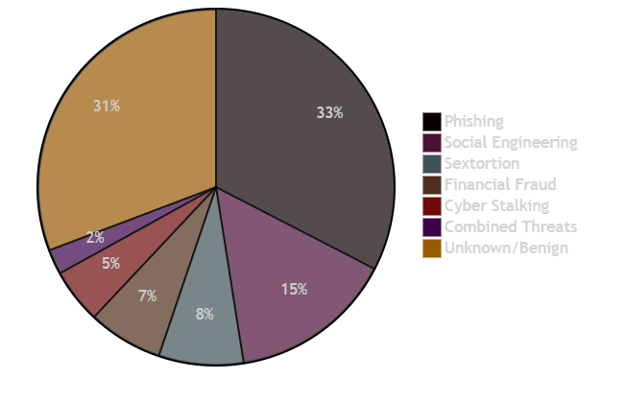

Fig 10.4.2 : Threat Engine Attack Vector Distribution

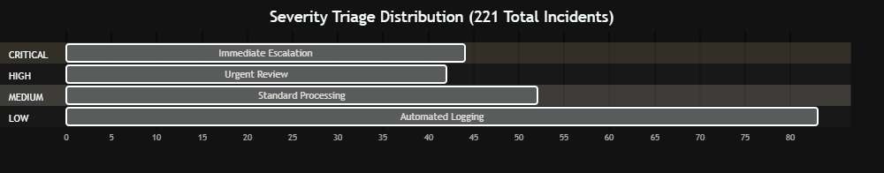

CHAPTER 11
APPLICATIONS

The W-CERT platform is architected for modular adaptability, facilitating its orchestration across diverse domains of cyber defense and digital forensic modernization:
- National & State CERTs: Serves as a centralized portal for secure incident reporting. The automated engine enables agencies to detect large-scale, coordinated attack vectors—such as regional phishing campaigns—without manual latency.
- Law Enforcement Agencies (LEAs): Empowers investigators with XAI-driven authenticity verification to validate synthetic media. By generating interpretable rationales and digital fingerprints, the platform ensures that digital artifacts remain legally admissible.
- Corporate Security Operations Centers (SOCs): Facilitates internal monitoring of data breaches and social engineering. Utilizing MITRE ATT&CK correlation, teams can proactively harden infrastructure against identified threat taxonomies.
- Humanitarian Organizations & NGOs: Provides a privacy-first vault specifically engineered for women-centric cyber emergencies, securing sensitive evidence through AES-256 encryption to prevent unauthorized exposure.

CHAPTER 12
CONCLUSION

- 12.1 Project Accomplishment
The W-CERT project has seen the completion of a fully working cloud native forensic intelligence ecosystem. The capstone project has been successful in converting manual incident response into a mathematically secured and automated process.
Using Explainable AI (XAI) techniques, the system addresses the problem of black box interpretation to provide legally admissible evidence of multimedia authenticity. Using SHA-256 and AES-256 algorithms at the ingestion phase sets up a thorough digital chain of custody. In addition, the decoupled design was highly resilient as it could classify incidents based on the standardized MITRE ATT&CK taxonomy without any delays.

- 12.2 Future Prospects
Although the current system has many features, the future development plans of the W-CERT ecosystem include several technological innovations in order to further boost its forensic and intelligence capabilities :
- Decentralized Chain of Custody: Moving to a decentralized chain of custody using blockchain technologies (e.g., Hyperledger) to remove the need for any central authority.
- Real-Time Video Forensic Analytics: Expanding XAI modules to support active video stream analysis for the detection of live face-swapping during synchronous communication.
- Automated Dark-Web Intelligence: Deploying proactive microservices to autonomously monitor dark-web forums for leaked telemetry or PII the moment an incident is triaged.

REFERENCES

[1] Z. Khalid, F. Iqbal, and B. C. M. Fung, "Towards a unified XAI-based framework for digital forensic investigations," Forensic Science International: Digital Investigation, 2024.
[2] N. Bharati, P. Wong, S. Kouadri Most&eacute;faoui, D. Kbaier, and J. Collie, "Explainable deepfake detection: A multi-model framework with human-interpretable rationales for legal investigation purposes," Machine Learning with Applications, vol. 23, p. 100819, 2025.
[3] F. Khalid, A. Javed, K. M. Malik, and A. Irtaza, "DFP-Net: An explainable and trustworthy framework for detecting deepfakes using interpretable prototypes," in IEEE International Joint Conference on Biometrics (IJCB), 2023.
[4] S. Tariq et al., "From Prediction to Explanation: Multimodal, Explainable, and Interactive Deepfake detection Framework for Non-Expert Users," Proceedings of the 33rd ACM International Conference on Multimedia, 2025.
[5] L. Xia, R. Ge, and Z. Jing, "From Black Boxes to Glass Boxes: Explainable AI for Trustworthy Deepfake Forensics," MDPI / Journal of Imaging, 2024.
[6] "Opportunities and Challenges of Artificial Intelligence in Digital Forensics," International Journal of Software Engineering and Computer Sciences (IJSECS), 2025.
[7] "A Multi-Protocol, Explainable AI-Based Framework for Real-Time IoT Forensics," in International Conference on Computing, Communication, Control and Cyber-Physical Systems (I5CPS), 2026.
[8] M. H. Maruf, "Developing an Explainable AI System for Digital Forensics: Enhancing Trust and Transparency in Flagging Events for Legal Evidence," ResearchGate, 2025.
[9] S. H. Silva et al., "Deepfake forensics analysis: An explainable hierarchical ensemble of weakly supervised models," Forensic Science International: Synergy, vol. 4, p. 100217, 2022.
[10] B. Saha and A. K. Khan, "Investigation of AI-based Deepfake Evidence: A Digital Forensics Approach," ResearchGate, 2026.
[11] T. O&apos;Brien, "MITRE ATT&amp;CK Labeling of Cyber Threat Intelligence via LLM," SANS Technology Institute Research Papers, 2025.
[12] "MITRE ATT&amp;CK Applications in Cybersecurity and The Way Forward," arXiv preprint arXiv:2502.10825, 2025.
[13] "MITRE ATT&amp;CK: State of the Art and Way Forward," ResearchGate, 2024.
[14] C. Ekisa and D. &Oacute; Briain, "Leveraging the MITRE ATT&amp;CK Framework for Threat Identification and Evaluation in Industrial Control System Simulations," in IEEE Conference Publication, 2024.
[15] G. P. Singh, J. K. Sandhu, and M. K. Hooda, "NLP-based Cyber Threat Data Analysis with MITRE ATT&amp;CK Techniques," ResearchGate, 2023.
[16] B. Al-Sada, A. Sadighian, and G. Oligeri, "Analysis and Characterization of Cyber Threats Leveraging the MITRE ATT&amp;CK Database," IEEE Access, 2023.
[17] "Cybersecurity Threat Intelligence Automated via Machine Learning: A System for Analyzing and Responding to Data in Real-Time," in IEEE Conference Publication, 2025.
[18] "Applying AI and Machine Learning to Enhance Automated Cybersecurity and Network Threat Identification," ResearchGate, 2024.
[19] I. A. Haji, S. D. Mohammed, and K. M. Mousa, "Blockchain based chain of custody and digital evidence legality in post conflict prosecutions," Frontiers in Blockchain, 2026.
[20] M. T. P. Mukti et al., "Blockchain-Based Chain of Custody in Digital Forensics: Ensuring Integrity and Legal Admissibility of Evidence," Forensics &amp; Security Journal (Journal of Ekantara), vol. 1, no. 1, 2025.
[21] D. Batista et al., "Exploring Blockchain Technology for Chain of Custody Control in Physical Evidence: A Systematic Literature Review," Journal of Risk and Financial Management, vol. 16, no. 8, p. 360, 2023.
[22] S. Nath, K. Summers, and J. Baek, "Digital Evidence Chain of Custody: Navigating New Realities of Digital Forensics," in 2024 IEEE 6th International Conference on Trust, Privacy and Security in Intelligent Systems, and Applications (TPS-ISA), 2024, pp. 11-20.
[23] "Blockchain-Based Chain of Custody Evidence Management System for Digital Forensic Investigations," in IEEE Conference Publication, 2024.
[24] K. M. M. Salih and N. Ibrahim, "CustodyChainGuardian: Blockchain of Custody Digital Evidence Preservation System," in IEEE Asia-Pacific Conference, 2023.
[25] "Management of the Chain of Custody of Digital Evidence Using Blockchain and Self-Sovereign Identities: A Systematic Literature Review," IEEE Access, 2025.

PART - B: INDIVIDUAL CONTRIBUTION

Problem Statement: Conventional incident response architectures are hindered by a critical inability to autonomously prioritize evolving cyber threats. There exists a manifest need for a centralized, scalable API ecosystem engineered to ingest raw telemetry, programmatically correlate metadata against global threat taxonomies such as MITRE ATT&CK, and dynamically orchestrate escalation workflows with zero manual latency.
Name of the Student: Nishinth Venkatesh
Module Title: API Architecture, Threat Intelligence Modeling, and Cloud Deployment
Project's Module Objectives - Individual Perspective
- To engineer a stateless, RESTful API backend utilizing the Python/Flask ecosystem, functioning as the primary routing engine for the W-CERT platform.
- To design and deploy a heuristic Threat Intelligence Engine capable of autonomous parsing and mapping of incident telemetry to established cyber threat vectors.
- To architect a resilient cloud-native deployment pipeline to ensure high availability and operational persistence of core backend microservices.
Project's Module Scope - Individual Perspective: The scope of this specialized module encompasses the end-to-end backend routing infrastructure (including incident and escalation routing protocols), the algorithmic development of the threat correlation engine, and the orchestration of production environment variables within containerized cloud instances. It excludes cryptographic implementations and frontend UI rendering logic.
Project's Module(s) - Individual Contribution: As the Principal Architect, my primary orchestration involved the development of the platform&apos;s core analytical routing layer. I engineered the Flask API endpoints to facilitate seamless communication between the React frontend and the forensic database. This included building the Threat Intelligence Engine, which utilizes weighted algorithms to analyze incident descriptions, assign severity classifications from Low to Critical, and autonomously identify attack vectors. Furthermore, I managed the decoupled integration of the XAI and security modules to ensure parallel processing during incident ingestion.
Hardware & Software Requirements
- Software Infrastructure: Python 3.10+, Flask, Waitress WSGI server, and Postman for rigorous API validation.
- Hardware Specifications: Development machines with 8GB RAM and containerized Render cloud instances for production deployment.

Module Interfaces
- External Interfaces: Exposes secure JSON endpoints for incident ingestion and retrieval, while interfacing with cloud provider APIs for automated CI/CD orchestration.
- Internal Interfaces: Facilitates high-fidelity asynchronous communication with the internal Cryptography and XAI modules to trigger specialized forensic functions.
Module Dependencies
- Dependent on JWT-based middleware for the enforcement of secure, authenticated routing.
- Logically dependent on the database persistence layer to commit and store processed forensic telemetry.
- Requires correctly structured multipart/form-data and JSON payloads delivered from the frontend interface.
Module Design: The architecture utilizes a Microservices-Oriented routing pattern, partitioning the API into specialized blueprints for authentication and incident management. The Threat Engine is engineered as a standalone utility class, utilizing mapped dictionaries of indicators to ensure O(1) lookup efficiency and rapid metadata analysis.
Module Implementation: Implementation involved orchestrating the Flask context while enforcing strict CORS policies for backend security. The Threat Engine utilizes custom algorithms to scan forensic descriptions for categorized keywords, aggregating a localized threat score and appending severity tags prior to database routing.
Module Testing Strategies: Rigorous endpoint validation was performed utilizing Postman, where test suites simulated malformed payloads, oversized file uploads, and unauthorized access attempts to verify that the error-handling middleware gracefully maintains system resilience.
Module Deployment: The backend module was containerized and deployed as a managed web service on Render. Security by Design was enforced by decoupling sensitive environment variables from the codebase and securely injecting them into the production dashboard.

PART - B: INDIVIDUAL CONTRIBUTION

Problem Statement: Digital forensic evidence is characterized by extreme volatility and susceptibility to tampering during network ingestion. In the absence of mathematically verifiable mechanisms to establish integrity at the point of upload, digital artifacts remain legally inadmissible. Furthermore, the storage of Personally Identifiable Information (PII) necessitates advanced encryption to mitigate privacy risks in the event of a database compromise.
Name of the Student: Ayush Dhore
Module Title: Cryptographic Infrastructure & Secure Backend Connection
Project's Module Objectives - Individual Perspective
- To engineer an automated SHA-256 hashing pipeline to establish a mathematically irrefutable digital chain of custody for all multimedia evidence.
- To implement AES-256 encryption protocols to secure sensitive victim PII at rest within the forensic repository.
- To develop and manage the secure programmatic interface between the Python backend and the persistent database architecture.
Project's Module Scope - Individual Perspective: The scope of this module includes the engineering of specialized security utility scripts for hashing and encryption, alongside the development of the database communication layer. It focuses strictly on data integrity, security protocols, and persistence, excluding frontend UI and machine learning inference logic.
Project's Module(s) - Individual Contribution: I took ownership of the platform&apos;s cryptographic security and data persistence layers. I developed the algorithms that intercept evidence files at the point of ingestion, processing them in binary chunks to generate unique 256-bit digital fingerprints. Additionally, I implemented AES encryption logic to secure victim metadata before storage. Finally, I configured the cloud service accounts and engineered the integration scripts to securely push processed forensic payloads to the immutable database in real-time.
Hardware & Software Requirements
- Software Infrastructure: Python 3.10+, hashlib, PyCryptodome for AES implementation, and Google API integration libraries.
- Hardware Specifications: Standard development machines with isolated secure storage for environment keys.
Module Interfaces
- External Interfaces: Directly communicates with cloud storage and database APIs utilizing secure OAuth2 Service Account credentials.
- Internal Interfaces: Provides core cryptographic utilities, including PII encryption and content hashing, which are invoked by the primary API routing logic.
Module Dependencies
- Dependent on API routing to pass raw file streams for cryptographic processing.
- Reliant on cloud infrastructure uptime for persistent database write operations.
- Mandates the strict management of isolated environment variables for service accounts and encryption keys.
Module Design: The module utilizes a functional utility pattern where cryptographic transformations are stateless to minimize memory overhead. The database interface integrates a localized caching mechanism to ensure operational continuity within API rate limitations.
Module Implementation: Implementation involved processing evidence in 64KB chunks to prevent RAM exhaustion. Sensitive telemetry is secured utilizing AES-256 in CBC mode, with the database connection mapped to predefined schemas to ensure forensic record consistency.
Module Testing Strategies: Testing was performed through rigorous unit validation, specifically targeting collision and tampering scenarios to verify that minute alterations to digital artifacts result in completely unique cryptographic signatures.
Module Deployment: Deployment necessitated the generation of restricted service credentials and the secure injection of symmetric keys into the cloud environment, ensuring critical security parameters remain decoupled from the public codebase.

PART - B: INDIVIDUAL CONTRIBUTION

Problem Statement: The proliferation of generative AI and synthetic media has compromised the reliability of visual inspection in digital forensics. While traditional deep learning can identify anomalies, these &quot;black-box&quot; models fail to provide interpretable rationales for their decisions, rendering detection outputs legally inadmissible in judicial proceedings.
Name of the Student: Neel Karnavat
Module Title: XAI & ML Evidence Training (Authenticity Checker)
Project's Module Objectives - Individual Perspective
- To develop a Deep Learning model engineered to detect pixel-level anomalies and synthetic media manipulations in forensic evidence.
- To integrate Explainable AI (XAI) algorithms to transform detection into a transparent, &quot;glass-box&quot; format.
- To autonomously generate human-interpretable visual proofs that mathematically delineate regions of digital tampering.
Project's Module Scope - Individual Perspective: The scope of this module focuses entirely on the machine learning pipeline, encompassing dataset acquisition, image preprocessing, CNN training, and the implementation of SHAP/LIME explanation frameworks. It excludes database management and frontend UI development.
Project's Module(s) - Individual Contribution: I engineered the platform&apos;s core forensic Authenticity Checker. My research involved gathering industry-standard datasets to train a deep learning network to identify imperceptible inconsistencies in pixel compression and lighting. Crucially, I integrated XAI frameworks to ensure that detection outputs include dynamic heatmaps, providing investigators with the exact coordinates of digital forgery to establish legal trustworthiness.
Hardware & Software Requirements
- Software Infrastructure: Python 3.10+, TensorFlow/PyTorch, OpenCV for image normalization, and SHAP/LIME libraries.
- Hardware Specifications: Workstations with NVIDIA CUDA-compatible GPUs for intensive mathematical computation during model training.
Module Interfaces
- Internal Interfaces: Provides a robust function that accepts raw multimedia byte-streams and returns a structured JSON dictionary containing confidence scores and visual forensic rationales.
Module Dependencies
- Dependent on the frontend for strict enforcement of file-type validation.
- Reliant on industry-standard forensic datasets for the training of accurate model weights.
Module Design: The module is designed as an isolated inference engine utilizing a Singleton pattern to load weights into memory once, thereby optimizing resource consumption during simultaneous forensic requests.
Module Implementation: Implementation involved building image-processing pipelines to normalize telemetry. The core logic utilizes gradient-based algorithms to measure network perturbations, identifying manipulated pixel coordinates with high fidelity.
Module Testing Strategies: Testing was benchmark-driven, utilizing False Positive and False Negative rates to iteratively refine hyperparameters until detection accuracy exceeded established forensic standards.
Module Deployment: Finalized model weights were serialized for deployment. The inference logic was optimized for cloud CPU instances to ensure economic viability while maintaining real-time visualization capabilities.

PART - B: INDIVIDUAL CONTRIBUTION

Problem Statement: Contemporary cybersecurity reporting architectures and SOC management consoles are hindered by systemic complexity, lacking the intuitive reactivity required during high-stress incident lifecycles. Conversely, forensic analysts require a high-performance orchestration console capable of visualizing massive threat datasets and XAI-generated heatmaps with zero operational latency or asynchronous delay.
Name of the Student: Sarthak Paymode
Module Title: Frontend UI/UX, Console Architecture, and React/Node.js Integration
Project's Module Objectives - Individual Perspective
- To design and engineer a highly responsive, component-based Graphical User Interface (GUI) optimized for incident reporting and real-time forensic orchestration.
- To architect a secure, asynchronous ingestion pipeline capable of handling high-fidelity multimedia evidence payloads with zero data corruption.
- To implement a dynamic state management framework to facilitate the real-time rendering of forensic telemetry, including Threat Scores and XAI heatmaps.
Project's Module Scope - Individual Perspective: The scope of this specialized module is strictly focused on the client-side microservices architecture (w-cert-frontend). This encompasses UI/UX orchestration, React.js component engineering, dynamic routing, and the deployment of Axios for secure HTTP communication. It excludes backend analytical engines and machine learning training logic.
Project's Module(s) - Individual Contribution: As the Lead Frontend Engineer, I directed the development of the platform&apos;s visual and interactive layers. I engineered the secure authentication middleware, the incident ingestion forms, and the centralized Analyst Dashboard. My primary contribution involved the development of complex logic to handle multipart/form-data, ensuring that intensive multimedia artifacts are efficiently buffered prior to backend transmission. Additionally, I orchestrated the dynamic data grids for severity-based threat prioritization and developed the console overlays that project XAI heatmaps onto forensic artifacts for enhanced analyst interpretation.
Hardware & Software Requirements
- Software Dependencies: Node.js (ver. 18+), React.js, Vite project orchestrator, Axios, and Tailwind CSS.
- Hardware Configurations: Development machine configurations; High availability cloud computing using Vercel's serverless edge network.
Module Interfaces
- Interfaces With the External System: Acts as the main point of user interaction, exchanging data with the Python / Flask based back end using HTTPS requests.
- Interfaces With the Internal Systems: Employs the React.js context APIs along with specific hooks for managing session and telemetry information.
Dependencies between Modules:
Depends on the consistent execution of RESTful services and JSON schema definitions from the Python backend.
Uses JSON Web Token (JWT)-secured session tokens to preserve persistent user log-ins and secure local storage accesses.
Design of Module: The frontend implements the Component Based Architecture (CBA) in a Single Page Application (SPA) design pattern using React Hooks. Decoupling of modular components allows the dashboard to render only relevant telemetry updates and achieve peak investigator performance.
Implementation of Module: Implementation entailed bootstrapping the system using Vite and setting up global Axios interceptors for injecting JWTs automatically. Modern CSS approaches were used to achieve the professional look expected of forensic command centers.
Testing of Module: Validation was done through cross-browser compatibility testing and responsiveness testing at different resolutions. Network telemetry was used to confirm that no memory leaks occurred when handling large payloads of evidence.
Deployment of Module: Client-side deployment was done on Vercel, leveraging CI/CD. Routing was set up in the vercel.json file to ensure that single-page application routing was not broken and avoided 404 errors on direct route access.
Project to Outcome Mapping Table

Table B.1 : Project to Outcome Mapping (Individual Contributions)
Sr. No. | PRN No. | Student Name | Individual Project Student Specific Objective | Learning Outcomes mapped
1 | 1032220939 | Nishinth Venkatesh | To engineer REST API routing, manage cloud deployments, and automate threat triage via MITRE ATT&CK modeling.
2 | 1032220255 | Ayush Dhore | To secure evidence via SHA-256 hashing and establish an encrypted (AES-256) connection to the database.
3 | 1032220469 | Neel Karnavat | To train a detection model and implement XAI to provide interpretable visual proofs of forged digital evidence.
4 | 1032220213 | Sarthak Paymode | To engineer a secure React dashboard for asynchronous multimedia uploads and real-time threat visualization.

